XGBoost Algorithm

Introduction
XGBoost stands for “Extreme Gradient Boosting”. XGBoost is an optimized distributed gradient boosting library designed to be highly efficient, flexible, and portable. It implements Machine Learning algorithms under the Gradient Boosting framework. It provides a parallel tree boosting to solve many data science problems in a fast and accurate way.
XGBoost is a software library that you can download and install on your machine, then access from a variety of interfaces. Specifically, XGBoost supports the following main interfaces:
- Command Line Interface (CLI).
- C++ (the language in which the library is written).
- Python interface as well as a model in scikit-learn.
- R interface as well as a model in the caret package.
- Julia.
- Java and JVM languages like Scala and platforms like Hadoop.

XGBoost Features
The library is laser-focused on computational speed and model performance, as such there are few frills. Nevertheless, it does offer a number of advanced features.

Model Features
The implementation of the model supports the features of the scikit-learn and R implementations, with new additions like regularization. Three main forms of gradient boosting are supported:
- Gradient Boosting algorithm also called gradient boosting machine including the learning rate.
- Stochastic Gradient Boosting with sub-sampling at the row, column, and column per split levels.
- Regularized Gradient Boosting with both L1 and L2 regularization.

System Features
The library provides a system for use in a range of computing environments, not least:
- Parallelization of tree construction using all of your CPU cores during training.
- Distributed Computing for training very large models using a cluster of machines.
- Out-of-Core Computing for very large datasets that don’t fit into memory.
- Cache Optimization of data structures and algorithm to make the best use of hardware.

Algorithm Features
The implementation of the algorithm was engineered for the efficiency of computing time and memory resources. A design goal was to make the best use of available resources to train the model. Some key algorithm implementation features include:
- Sparse Aware implementation with automatic handling of missing data values.
- Block Structure to support the parallelization of tree construction.
- Continued Training so that you can further boost an already fitted model on new data.
XGBoost is free open-source software available for use under the permissive Apache-2 license.

Why Use XGBoost?
The two reasons to use XGBoost are also the two goals of the project:
- Execution Speed.
- Model Performance.
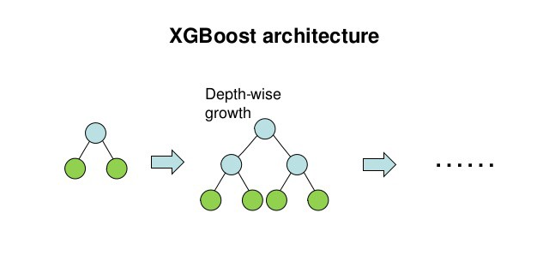

What is Boosting…?
Boosting is an ensemble learning technique to build a strong classifier from several weak classifiers in series. Boosting algorithms play a crucial role in dealing with bias-variance trade-offs. Unlike bagging algorithms, which only control for high variance in a model, boosting controls both the aspects (bias & variance) and is considered to be more effective.
Below are the few types of boosting algorithms:
- AdaBoost (Adaptive Boosting)
- Gradient Boosting
- XGBoost
- CATBoost
- Light GBM

AdaBoost
AdaBoost is short for Adaptive Boosting. AdaBoost was the first successful boosting algorithm developed for binary classification. Also, it is the best starting point for understanding boosting algorithms. It is adaptive in the sense that subsequent classifiers built are tweaked in favor of those instances misclassified by previous classifiers. It is sensitive to noisy data and outliers.
AdaBoost uses multiple iterations to generate a single composite strong learner. It creates a strong learner by iteratively adding weak learners. During each phase of training, a new weak learner is added to the ensemble, and a weighting vector is adjusted to focus on examples that were misclassified in previous rounds. The result is a classifier that has higher accuracy than the weak learner classifiers.
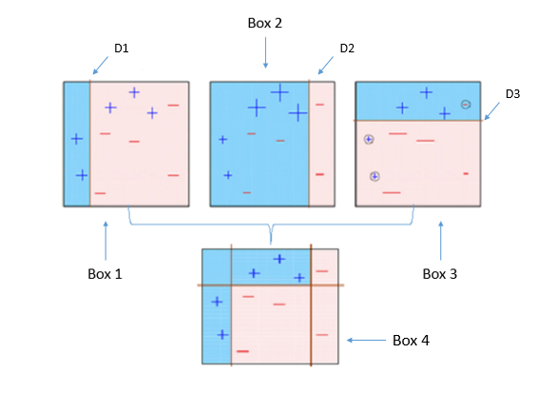

Gradient Boosting
Gradient boosting is one of the most powerful techniques for building predictive models, and it is called a Generalization of AdaBoost. The main objective of Gradient Boost is to minimize the loss function by adding weak learners using a gradient descent optimization algorithm. The generalization allowed arbitrary differentiable loss functions to be used, expanding the technique beyond binary classification problems to support regression, multi-class classification, and more.
Gradient Boost has three main components.
- Loss Function: The role of the loss function is to estimate how best is the model in making predictions with the given data. This could vary depending on the type of problem.
- Weak Learner: Weak learner is one that classifies the data so poorly when compared to random guessing. The weak learners are mostly decision trees, but other models can be used in GBM.
- Additive Model: It is an iterative and sequential process in adding the decision trees one step at a time. Each iteration should reduce the value of the loss function. A fixed number of trees are added, or training stops once loss reaches an acceptable level or no longer improves on an external validation dataset.

Improvements to Gradient Boosting
Gradient boosting is a greedy algorithm and can overfit a training dataset quickly. So regularization methods are used to improve the performance of the algorithm by reducing overfitting.
- Subsampling: This is the simplest form of regularization method introduced for GBM’s. This improves the generalization properties of the model and reduces the computation efforts. Subsampling introduces randomness into the fitting procedure. At each learning iteration, only a random part of the training data is used to fit a consecutive base-learner. The training data is sampled without replacement.
- Shrinkage: Shrinkage is commonly used in ridge regression where it shrinks regression coefficients to zero and, thus, reduces the impact of potentially unstable regression coefficients. In GBM’s, shrinkage is used for reducing the impact of each additionally fitted base-learner. It reduces the size of incremental steps and thus penalizes the importance of each consecutive iteration. The intuition behind this technique is that it is better to improve a model by taking many small steps than by taking fewer large steps. If one of the boosting iterations turns out to be erroneous, its negative impact can be corrected easily in subsequent steps.
- Early Stopping: One important practical consideration that can be derived from Decision Tree is early stopping or tree pruning. This means that if the ensemble was trimmed by the number of trees, corresponding to the validation set minima on the error curve, the overfitting would be circumvented at the minimal accuracy expense. Another observation is that the optimal number of boosts, at which the early stopping is considered, varies concerning the shrinkage parameter λ. Therefore, a trade-off between the number of boosts and λ should be considered.
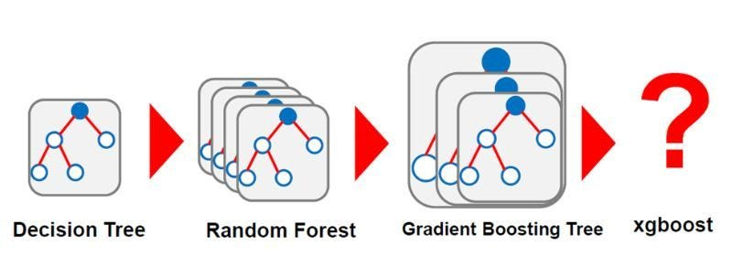

XGBoost
XGBoost stands for eXtreme Gradient Boosting. It became popular in recent days and is dominating applied machine learning and Kaggle competitions for structured data because of its scalability.
XGBoost is an extension to gradient boosted decision trees (GBM) and specially designed to improve speed and performance.

XGBoost Features
- Regularized Learning: The regularization term helps to smooth the final learned weights to avoid over-fitting. The regularized objective will tend to select a model employing simple and predictive functions.
- Gradient Tree Boosting: The tree ensemble model cannot be optimized using traditional optimization methods in Euclidean space. Instead, the model is trained in an additive manner.
- Shrinkage and Column Subsampling: Besides the regularized objective, two additional techniques are used to further prevent overfitting. The first technique is shrinkage introduced by Friedman. Shrinkage scales newly added weights by a factor η after each step of tree boosting. Similar to a learning rate in stochastic optimization, shrinkage reduces the influence of each tree and leaves space for future trees to improve the model.
The second technique is the column (feature) subsampling. This technique is used in Random Forest. Column sub-sampling prevents over-fitting even more so than the traditional row sub-sampling. The usage of column sub-samples also speeds up computations of the parallel algorithm.

SPLITTING ALGORITHMS
- Exact Greedy Algorithm: The main problem in tree learning is to find the best split. This algorithm enumerates all the possible splits on all the features. It is computationally demanding to enumerate all the possible splits for continuous features.
- Approximate Algorithm: The exact greedy algorithm is very powerful since it enumerates overall possible splitting points greedily. However, it is impossible to efficiently do so when the data does not fit entirely into memory. Approximate Algorithm proposes candidate splitting points according to percentiles of feature distribution. The algorithm then maps the continuous features into buckets split by these candidate points, aggregates the statistics, and finds the best solution among proposals based on the aggregated statistics.
- Weighted Quantile Sketch: One important step in the approximate algorithm is to propose candidate split points. XGBoost has a distributed weighted quantile sketch algorithm to effectively handle weighted data.
- Sparsity-aware Split Finding: In many real-world problems, it is quite common for the input x to be sparse. There are multiple possible causes for sparsity:
- Presence of missing values in the data
- Frequent zero entries in the statistics
- Artifacts of feature engineering such as one-hot encoding
It is important to make the algorithm aware of the sparsity pattern in the data. XGBoost handles all sparsity patterns in a unified way.

System Features of XGBoost
- Parallelization of tree construction using all of your CPU cores during training. Collecting statistics for each column can be parallelized, giving us a parallel algorithm for split finding.
- Cache-aware Access: XGBoost has been designed to make optimal use of hardware. This is done by allocating internal buffers in each thread, where the gradient statistics can be stored.
- Blocks for Out-of-core Computation for very large datasets that don’t fit into memory.
- Distributed Computing for training very large models using a cluster of machines.
- Column Block for Parallel Learning. The most time-consuming part of tree learning is to get the data into sorted order. In order to reduce the cost of sorting, the data is stored in the column blocks in sorted order in compressed format.

Goals of XGBoost
- Execution Speed: XGBoost was almost always faster than the other benchmarked implementations from R, Python Spark, and H2O and it is really faster when compared to the other algorithms.
- Model Performance: XGBoost dominates structured or tabular datasets on classification and regression predictive modeling problems.

XGBoost Algorithm — Parameters

a. General Parameters
Following are the General parameters used in Xgboost Algorithm:
- silent: The default value is 0. You need to specify 0 for printing running messages, 1 for silent mode.
- booster: The default value is GBtree. You need to specify the booster to use: GBtree (tree-based) or GBlinear (linear function).
- num_pbuffer: This is set automatically by XGBoost Algorithm, no need to be set by a user. Read the documentation of XGBoost for more details.
- num_feature: This is set automatically by XGBoost Algorithm, no need to be set by a user.

b. Booster Parameters
Below we discussed tree-specific parameters in Xgboost Algorithm:
- eta: The default value is set to 0.3. You need to specify step size shrinkage used in an update to prevents overfitting. After each boosting step, we can directly get the weights of new features. eta actually shrinks the feature weights to make the boosting process more conservative. The range is 0 to 1. Low eta value means the model is more robust to overfitting.
- gamma: The default value is set to 0. You need to specify the minimum loss reduction required to make a further partition on a leaf node of the tree. The larger, the more conservative the algorithm will be. The range is 0 to ∞. The larger the gamma more conservative the algorithm is.
- max_depth: The default value is set to 6. You need to specify the maximum depth of a tree. The range is 1 to ∞.
- min_child_weight: The default value is set to 1. You need to specify the minimum sum of instance weight(hessian) needed in a child. If the tree partition step results in a leaf node. Then with the sum of instance weight less than min_child_weight. Then the building process will give up further partitioning. In linear regression mode, corresponds to a minimum number of instances needed to be in each node. The larger, the more conservative the algorithm will be. The range is 0 to ∞.
- max_delta_step: The default value is set to 0. Maximum delta step we allow each tree’s weight estimation to be. If the value is set to 0, it means there is no constraint. If it is set to a positive value, it can help make the update step more conservative. Usually, this parameter is not needed, but it might help in logistic regression. Especially, when a class is extremely imbalanced. Set it to a value of 1–10 might help control the update. The range is 0 to ∞.
- subsample: The default value is set to 1. You need to specify the subsample ratio of the training instance. Setting it to 0.5 means that XGBoost randomly collected half of the data instances. That needs to grow trees and this will prevent overfitting. The range is 0 to 1.
- colsample_bytree: The default value is set to 1. You need to specify the subsample ratio of columns when constructing each tree. The range is 0 to 1.

c. Linear Booster Specific Parameters
These are Linear Booster Specific Parameters in XGBoost Algorithm.
- lambda and alpha: These are regularization terms on weights. Lambda default value assumed is 1 and alpha is 0.
- lambda_bias: L2 regularization term on bias and has a default value of 0.

d. Learning Task Parameters
Following are the Learning Task Parameters in XGBoost Algorithm
- base_score: The default value is set to 0.5. You need to specify the initial prediction score of all instances, global bias.
- objective: The default value is set to reg: linear. You need to specify the type of learner you want. That includes linear regression, Poisson regression, etc.
- eval_metric: You need to specify the evaluation metrics for validation data. And a default metric will be assigned according to the objective.
- seed: As always here you specify the seed to reproduce the same set of outputs.

Summary
In this post, you discovered the XGBoost algorithm for applied machine learning.
You learned:
- That XGBoost is a library for developing fast and high-performance gradient boosting tree models.
- That XGBoost is achieving the best performance on a range of difficult machine learning tasks.

Conclusion
XGBoost is a faster algorithm when compared to other algorithms because of its parallel and distributed computing. XGBoost is developed with both deep considerations in terms of systems optimization and principles in machine learning. The goal of this library is to push the extreme of the computation limits of machines to provide a scalable, portable, and accurate library.

